**DAILY ONLINE ACTIVITIES SUMMARY**

|  |  |  |  |  |  |  |
| --- | --- | --- | --- | --- | --- | --- |
| **Date:** | **03-05-2020** | | | **Name:** | **B.A.SOHANKUMAR** | |
| **Sem & Sec** | **4TH SEM A** | | | **USN:** | **4AL18CS013** | |
| **Online Test Summary** | | | | | | |
| **Subject** | | **OBJECT ORIENTED CONCEPT** | | | | |
| **Max. Marks** | | **30** | | **Score** | **13** | |
| **Certification Course Summary** | | | | | | |
| **Course** | **INTRODUCTION TO CYBER SECURITY** | | | | | |
| **Certificate Provider** | | | **GREAT LEARNING ACADEMY** | **Duration** | | **7 HOURS** |
| **Coding Challenges** | | | | | | |
| **Problem Statement:1:Write a code segment in java to swap two numbers using call by object reference.**  **Problem Statement:2:Write a java program to find last digit of a^b for large numbers.** | | | | | | |
| **Status: COMPLETED** | | | | | | |
| **Uploaded the report in Github** | | | | **YES** | | |
| **If yes Repository name** | | | | **LOCKDOWN CODING** | | |
| **Uploaded the report in slack** | | | | **YES** | | |

**ONLINE TEST DETAILS:**

The today's online test was from module 2 and 3 of OBJECT ORIENTED CONCEPT(18CS45).The duration of the test was 45 minutes from 09.15am to 10.00am.The questions were based on programs.Score I received is 13/30.

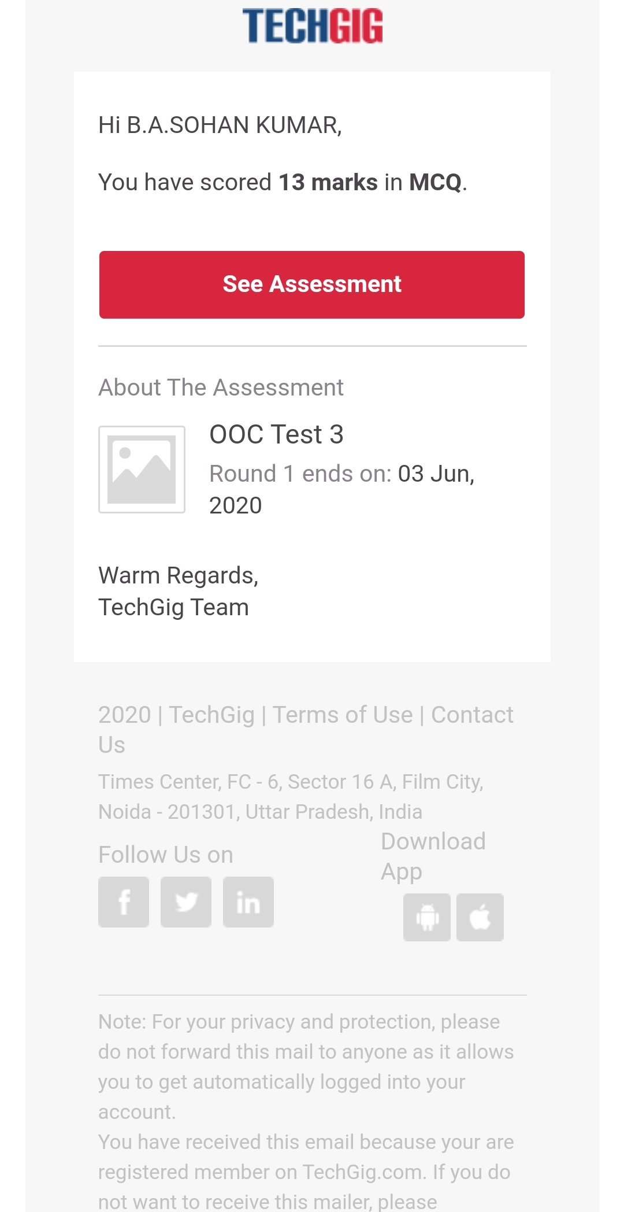

**CERTIFICATION COURSE DETAILS:**

Course: INTRODUCTION TO CYBER SECURITY

Today in this course I have completed three topics that are Blockchain in Cybersecurity,Career and Industry Landscape,Governance and Risk.

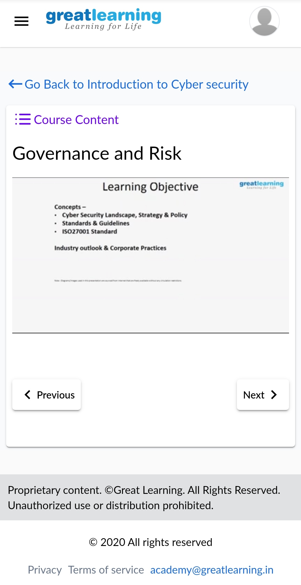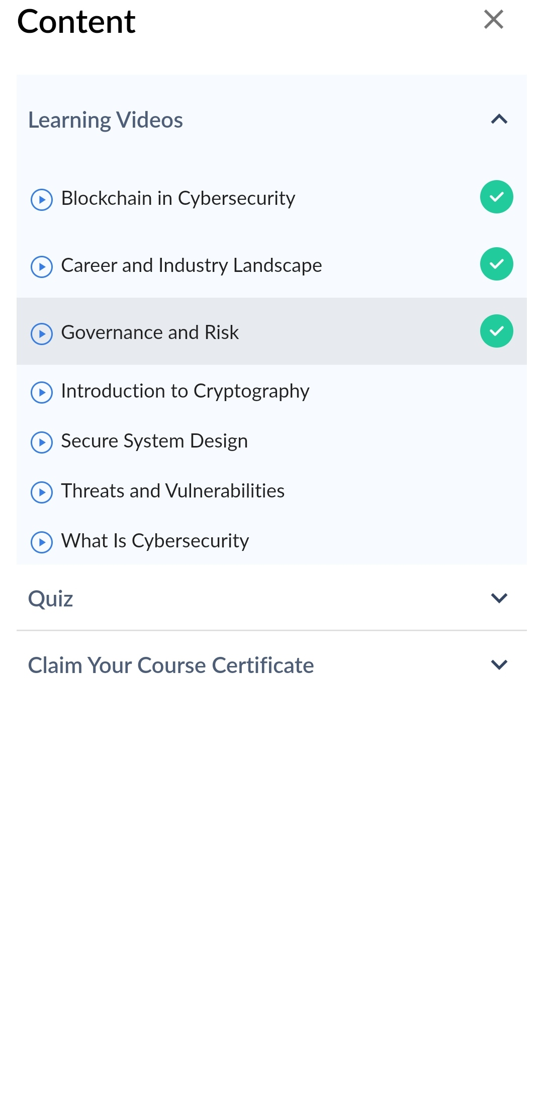

**CODING CHALLENGES DETAILS:**

1.Write a code segment in java to swap two numbers using call by object reference.

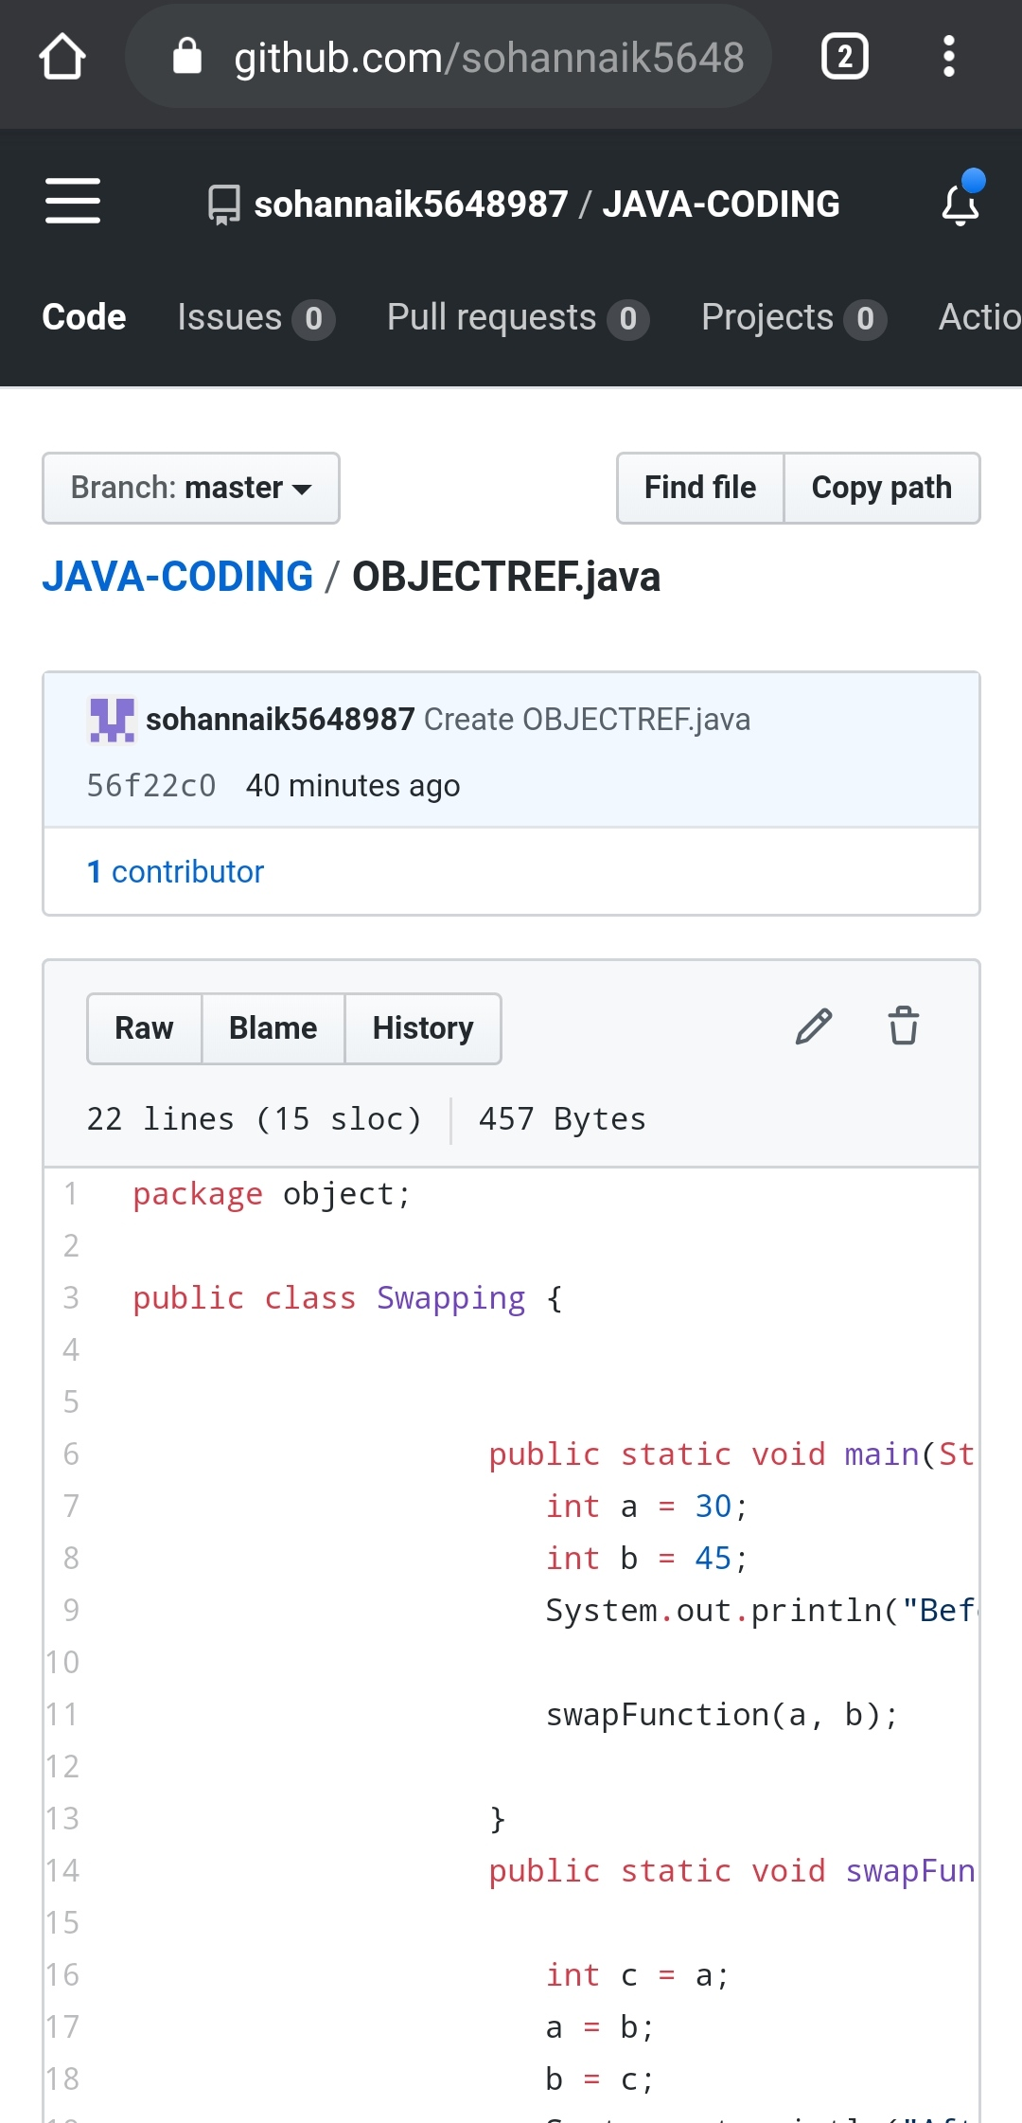

2.Write a java program to find last digit of a^b for large numbers.

You are given two integer numbers, the base a (number of digits d, such that 1 <= d <= 1000) and the index b (0 <= b <= 922*10^15). You have to find the last digit of a^b.

Input : 3 10

Output : 9

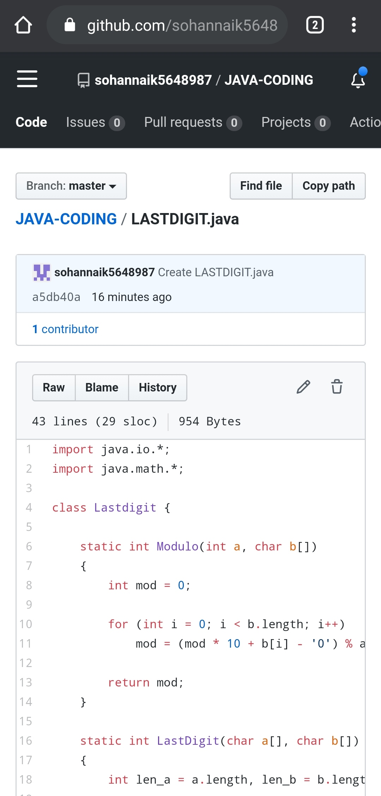

REPOSITORY LINK:https://github.com/sohannaik5648987/JAVA-CODING